**Computer Programming Report**

**Part 1**

*Planning:*

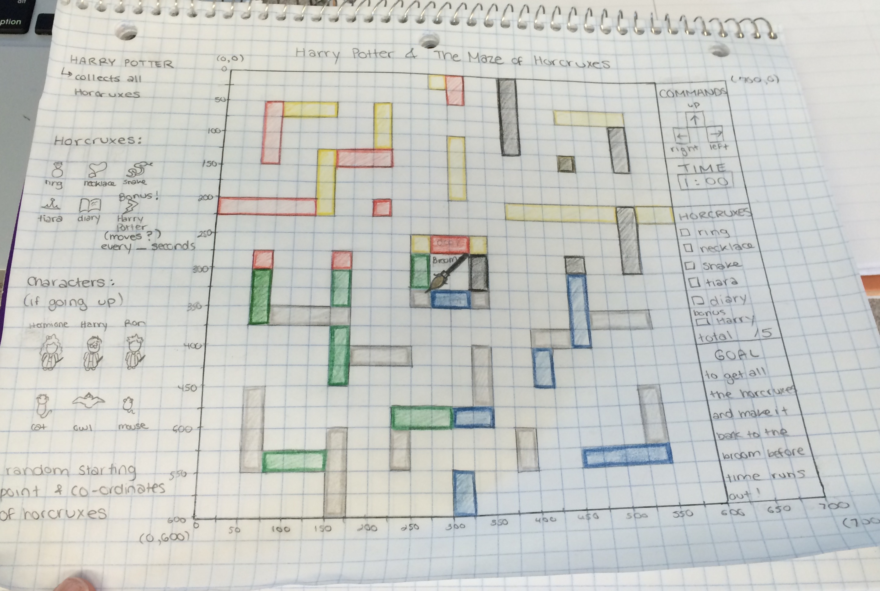

*Program Name:*

Harry Potter and the Maze of Horcruxes

*Goal:*

The goal is for the user to collect all of the Horcruxes, so that the broom will appear so they can escape, and the game will end.

*Purpose:*

The purpose is to create a moveable console maze where the user has to make it to the finish.

*Description:*

A Harry Potter character must collect all of the horcruxes in order to kill Voldemort and save the world.

*Instructions:*

Using the up, down, right or left key the user has to navigate through the maze to accumulate all of the horcruxes. Once the horcruxes have all been collected the broom will appear, and then the user will go towards the broom in order to win and end the program.

**Part 2***:*

*Program Name:*

MedFi

*Goal:*

The goal is for the user to search, edit or create a new file for their patients.

*Purpose:*

The purpose is to create a program using our past knowledge of computer programming like functions.

*Description:*

Using MedFi, the doctors can have an online storage base of all their patients new, edited or searched files.

*Instructions:*

Using the commands search, new, or edit the user can navigate through the files.